1.

2.

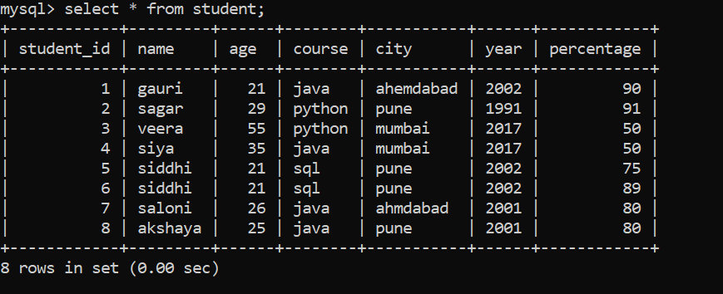

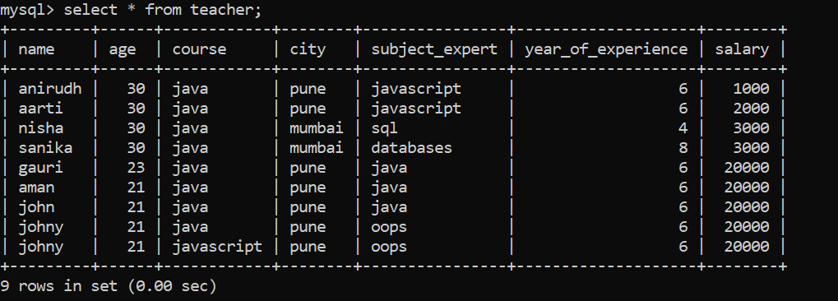

4.backup table of student

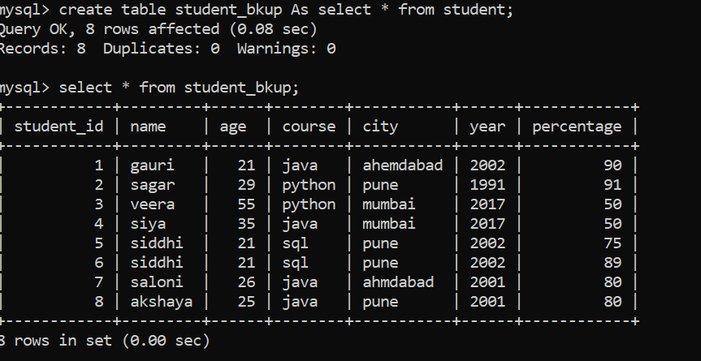

5.student from pune,mumbai

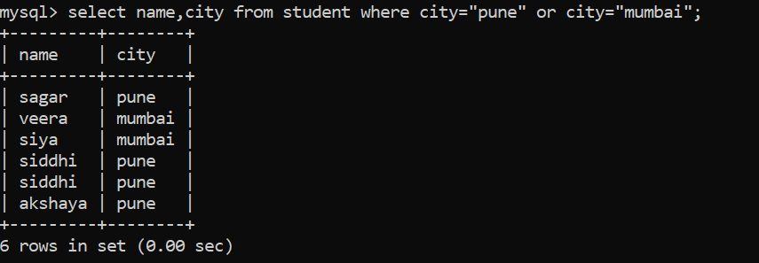

7.

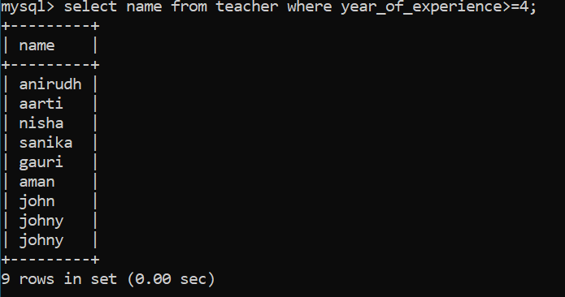

11.

mysql> CREATE TABLE backup_table1 AS SELECT * FROM student where 1!=1;

Query OK, 0 rows affected (0.07 sec)

Records: 0 Duplicates: 0 Warnings: 0

mysql> select * from backup_table1;

Empty set (0.00 sec)